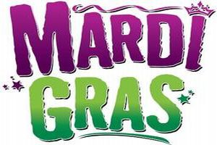
Save the dates!!
Here are our fun filled events for August & Labor Day Weekend:
Mardi Gras Dinner 8/8 @ Grassy Point 5:30
Bar Crawl 8/12 – Kickoff @ Grassy Point 2:00
Family Bingo 8/16 @ BCAC Field 6:30
Country Night 8/18 @ Ruffle Bar 8:30
Amazing Race/Scavenger Hunt 8/19 @ BCAC Field registration 1:00
Mardi Gras Dinner 8/22 @ Grassy Point 5:30
Adult Radio Bingo 8/25 @ American Legion 8:00
Adult Sunday Funday 8/27 @ BCAC Field @ 3:00
Mardi Gras Dinner 8/29 – Grassy Point 5:30
Kickball Tournament/ Countdown 9/1 @ BCAC Field registration 5:30 – limited space, sign up teams now
Family Fun Day 9/2 @ BCAC Field @ 1:00
Labor Day Parade 9/4
Don’t forget to get your chance for our summer end raffle, please contact Sabrina Gross 347-804-2764

