BCAC Shamrock
Summer Shootout

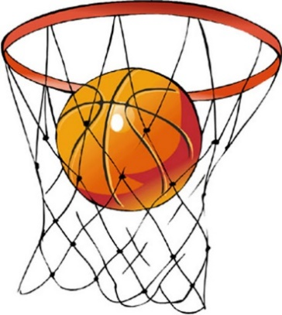

Registrations for the
2021 BCAC Shamrock Summer Shootout season
will be held at the BCAC on the following date:

Wednesday, April 21st, 6 – 8 pm
(FINAL REGISTRATION)

Boys and Girls from ages 4 to 15 years

Fee: $35.00 per child, $90 max per family

We are also in need of parent volunteers to help run the league.

*Please note that the 17th Road Park is scheduled for construction beginning early June which will hamper our 2021 season, but we will still have the league. The two basketball courts will be totally redone as will all the pavers and benches in the park. We will be able to use the hockey rink which we will convert to basketball for the season.

**Due to restrcitions with COVID and the impending construction to the park, registrations will only be accepted with payment on a first-come, first-serve basis.
Spots in each division are limited and not guaranteed. In the event that we are forced to cancel any sport season, the BCAC will be giving CREDIT for a future season in lieu of a refund.

