DIOCESE OF BROOKLYN/QUEENS
The following are steps that need to be taken to get registered as an ATHLETE
with the Catholic Youth Organization (CYO):
- Go to the website, cyodobathlete.arbitersports.com (THIS LINK CAN ALSO BE ACCESSED ON THE HOMEPAGE OF THE CYO WEBSITE – www.cyodob.org)
- Select the Registration tab, near the top of the page and then select the Athlete Registration option under Open Registrations
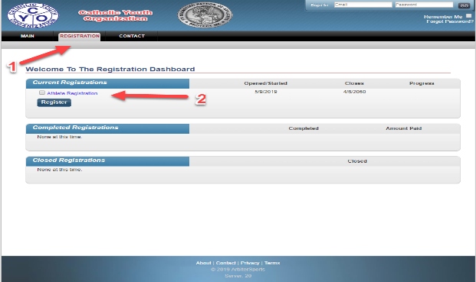
- Fill out ALL the required information for each step listed
  - The required steps will have a * on the right-hand side of it.
  - Payment required to complete registration
- Instructions to Register Multiple Family Members:
For the first child being registered, enter the email address you will be using for CYO. (ex: kgoldberg@gmail.com).
For each additional child being registered, you will need to add the plus sign and the child’s first name before the @ sign. (ex: email for Alex Goldberg would be entered as kgoldberg+alex@gmail.com)

- Select Finish after completing the last step in the registration process
- You will receive a Registration Completion email with your CYO MEMBERSHIP NUMBER, which will be required to complete your registration at a CYO parish program.

