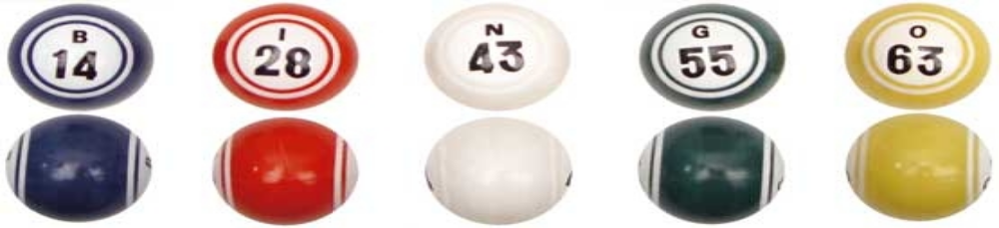n

FAMILY BINGO!
Wednesday, August 16th, 2017
Doors open 6:30 PM

Location: BCAC Field

$10 Family Admission – (Includes regular bingo cards)
Additional cards will be sold, early bird specials available as well

Great prizes & raffles

***Jackpot BINGO***

~ All proceeds benefit the B.C.A.C Mardi Gras 2017~
To reserve a table call Heidi @ 347-993-4904

