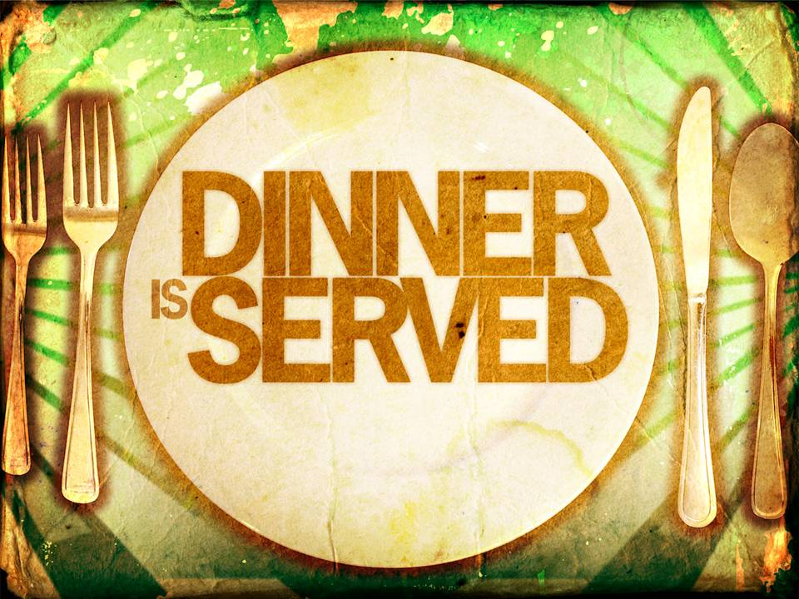
Too hot to cook? Let us cook for you!

Mardi Gras Dinner: Chicken Piccada w Rice & Peas
Date: Tuesday – August 8, 2017
Time: 5:30 pm – 8:00 pm
Place: Grassy Point Bar
Cost: $10.00
Phone: 718-474-1688
Free delivery, pick up or eat in.
Phone orders start @ 2:00
All proceeds go to BCAC Mardi Gras 2017

